<Enter project name here>dbEdit
Test plan
Version 1.0
April 24, 2020
Document Control
Approval
The Guidance Team and the customer shall approve this document.
Document Change Control
Initial Release: | 1.0
Current Release: | 1.0
Indicator of Last Page in Document: | 11
Date of Last Review: | 4/22/20
Date of Next Review: | NA
Target Date for Next Update: | NA
Distribution List
This following list of people shall receive a copy of this document every time a new version of this document becomes available:
Guidance Team Members:
Steve Roach

Customer:
Steve Roach

Software Team Members:
Denise G. Castro
Chris W. Santos
Ethan J. Hardin
Change Summary
The following table details changes made between versions of this document

Version | Date | Modifier | Description
1.0 | 4/13/20 | Denise Castro | Initial Documentation
2.0 | 4/24/20 | Denise Castro | Reviewed Documentation

Note: The template presented in this document was taken from:
Donaldson, S., and S. Siegel, Successful Software Development. Upper Saddle River, NJ: Prentice Hall, 2001, pp. 321-323.

Note: The template presented in this document was taken from: Donaldson, S., and S. Siegel, Successful Software Development. Upper Saddle River, NJ: Prentice Hall, 2001, pp. 321-323 and modified by Humberto Mendoza and Steve Roach.

Supplementary information is from:
Pfleeger, S. Software Engineering, Theory and Practice. Upper Saddle River, NJ: Prentice Hall, 1998, p. 365.

Table of Contents
Document Control ii
Approval ii
Document Change Control ii
Distribution List ii
Change Summary ii
1. Introduction 5
1.1. Purpose 5
1.2. Scope 5
1.3. System Overview 5
1.4. Suspension and Exit Criteria 5
1.5. Document Overview 5
1.6. References 5
2. Test Items and Features 6
3. Testing Approach 7
4. Test XX 8
4.1. Test 1 8
4.2. Test 2 9
4.3. Test 3 1
4.4. Test 4 1
4.5. Test 5 2
4.6. Test 6 2
5. User Interface Testing 3
6. Test Schedule 4
7. Other Sections 5
8. Appendix 6

Introduction

The system is a a database editor. That allows editing of data stored in XML tables but does not allow changes to the schema. This plan will test the file menu operations including the search options in that menu, without testing the file comparison function.

Purpose
This Test plan is testing the dbEdit. Which is a database editor project that allows editting without changing the schema. This test plan will test the file menu operations of this project. This project will be tested by going through each functionality of the menu as described in the specifications documents of the dbEdit project.

Scope
This plan is testing the dbEdit project available from April 6, 2020 on github. Tests the File menu operations excluding the file comparison but includes the search menu operations in the database window.

System Overview
“In this system, configuration data is stored in XML tables. A data table is named "databasename__tablename.xml". This file must be in the same directory as the database file. Any xml file in the database can have a history section, usually at the bottom of the file.”

Suspension and Exit Criteria

Suspension criteria consider testing suspending if step 1 in Test 1 failed.
Exit Criteria: Testing stops only when all tests are run.

Document Overview
Test cases found in section 4 and pictures of expected output found in Appendix. The appendix also contains some definitions or commonly used phrases through this document.

References
“spec” from Dr. Steve Roach.

Test Items and Features
File menu operations excluding compare file to other version, check for duplicate rows, and filter. This includes the search menu option on the database window. Excludes compare file function.

Testing Approach

Table 1: Test Plan
TEST SUITE dbEdit.jar
Description of Test Suite | Testing from dbEdit.jar GUI
Test Case Identifier | Objective | Criticality
Test 1 | This test is meant to approximate normal operation of the file search function | High
Test 2 | This test is meant approximate normal operations of file menu from database window. Specifically Open, and Close. | High
Test 3 | This test is meant approximate normal operations of file menu from data file window. Specifically Edit | High
Test 4 | This test is meant to approximate normal operations. Specifically tests Save and History. | High
Test 5 | This test is meant to check specifically for duplicate rows. As well as the AND/OR filter | High

Test XX

Test 1

Objective: This test is meant to approximate normal operation of the file search function.

Notes: Use folder that dbEdit.jar comes in. This folder has .xml files used to test this function.

Test No.: 1 |  |  |  | Current Status: << Passed / Failed / Pending >>
Test title: Search Test

Testing approach:

Will be testing using the dbEdit.jar GUI. Should be able to open the initial database window. This is a high priority test as the function is needed to work.
STEP  1  2  3  4  5 | OPERATOR ACTION  Execute dbEdit.jar  Click on “Search” in top left corner of window.  Select “Find Files”  From drop down  Click on “File Path” and set to dbEdit directory (C:\Users\Denise\Download\dbEdit\)  Enter “Constraint” into “Search For” space  Click button “Search”  Exit out of search window to database window | PURPOSE  Must be able to use in order to access search function.  Necessary for search function to find .xml files  Setting the directory for search testing  Ensure search function can find a specific file  Exit procedure |  |  | EXEPCTED RESULTS  GUI for dbEdit should open to initial database window. Which should have no database loaded  File Search window should open.  The path should display in prompt space next “File Path” button.  Display “TEST_DB_CONSTRAINT_TABLE.XML”  Search window closes | COMMENTS  If this step is failed consider all testing suspended  Figure 8.1.1  If this does not occur test has failed.  Figure 8.1.2  If this does not occur test has failed.  Use folder that dbEdit.jar comes in which contains .xml files.  Figure 8.1.3  The result is expected for the dbEdit.jar folder
Concluding Remarks: Please note here if test failed at which step.
Testing Team: |  |  | Date Completed:

Test 2

Objective: This test is meant approximate normal operations of file menu from database window. Specifically Open and Close.

Notes: Use folder in which dbEdit.jar comes in. This folder is used to ensure this function

Test No.: 2 |  |  |  | Current Status: << Passed / Failed / Pending >>
Test title: Open Close test

Testing approach: Will be testing using the dbEdit.jar GUI. This is a high priority test as the function is needed to work.
Precondition: Should open the initial database window.
STEP  1  2  3  4  5 | OPERATOR ACTION  From database window click “File” in top left corner. Then select “Open” from drop down menu  Open “TEST_DB.XML”  Double-Click on all three data files one at a time in order from top to bottom.  Click on database window to bring it to the front. Now click on top data file from database window.  From database window  Under “File” dropdown  Click “close” | PURPOSE  Initial function  Function of navigating from description files to data files.  Basic function  Basic function  Testing close function |  |  | EXEPCTED RESULTS  “File Search Path” window will open.  Database window will display 3 data tables that can be opened.  Multiple windows should open without closing any previous ones  Top file should come to the front of all other files  dbEdit GUI should close | COMMENTS  Make sure directory is set to the same folder that dbEdit.jar came in.  Figure 8.2.1  Figure 8.2.2  This will close all four windows open. The database window and three other data file windows.
Concluding Remarks: Please note here if test failed at which step.
Testing Team: |  |  | Date Completed:

Test 3

Objective: This test is meant approximate normal operations of file menu from data file window. Specifically Edit.

Notes: Needed the folder that dbEdit.jar comes in the data files are necessary for the test.

Test No.: 3 |  |  | Current Status: << Passed / Failed / Pending >>
Test title: Edit File Test

Testing approach: Will be testing using the dbEdit.jar GUI. This is a high priority test as the function is needed to work.
Precondition: Should open the initial database window of the dbEdit.jar.
STEP  1  2  3 | OPERATOR ACTION  Open dbEdit.jar From “File” dropdown menu click “Open” to open “TEST_DB.XML” Double-click on “TYPE-TABLE”  Click on a row in the file. On keyboard press ctrl+c press ctrl+v  Press ctrl+z | PURPOSE  Initial set up  Test edit function  Test undo edit function | EXEPCTED RESULTS  Two windows open. One for database window and one for data file “TYPE_TABLE”  File will paste row copied (ctrl+c) to file.  File will undo pasted row |  | COMMENTS  If there are no yellow rows to indicating duplicates or red rows indicating violation of constraints consider please note but proceed with test  Figure 8.3.1  If row is not copied test failed. if unsure choose a different row and repeat step.  If nothing undone test failed.
Concluding Remarks: Please note here if test failed at which step.
Testing Team: |  |  |  | Date Completed:

Test 4

Objective: Testing Save and History functions

Notes: Needed the folder that dbEdit.jar comes in the data files are necessary for the test.

Test No.: 4 |  |  |  | Current Status: << Passed / Failed / Pending >>
Test title: Save and History test

Testing approach: Will be testing using the dbEdit.jar GUI. This is a high priority test as the function is needed to work.
Precondition: Should open the initial database window of the dbEdit.jar.
STEP  1  2  3  4  5 | OPERATOR ACTION  From a data file window.  Use “Big Table” press ctrl+I  Exit window. top right corner  Press “Save” in prompt  Enter “TEST” in author  Enter “Inserted Row” in description. Click “OK”  Double-click on “Big Table” Click “Options” From dropdown menu click “History” | PURPOSE  Initial set up for test  Save prompt test  History prompt test  History prompt test  History Test |  |  | EXEPCTED RESULTS  New row should be inserted to file.  Save prompt appears  History Input prompt appears  Return to database window  History Window appears with a row that contains “TEST” under Author and “Inserted Row” under Description | COMMENTS  Figure 8.4.1  Figure 8.4.2  Figure 8.4.3  Figure 8.4.4
Concluding Remarks: Please note here if test failed at which step.
Testing Team: |  |  | Date Completed:

Test 5

Objective: This test is meant to check specifically for duplicate rows. As well as the AND/OR filter
Notes:Needed the folder that dbEdit.jar comes in the data files are necessary for the test.

Test No.: 5 |  |  |  | Current Status: << Passed / Failed / Pending >>
Test title: duplicates test

Testing approach: Will be testing using the dbEdit.jar GUI. This is a high priority test as the function is needed to work.
Precondition: Should open the initial database window of the dbEdit.jar.
STEP  1  2  3 | OPERATOR ACTION  Open “Cosntraint_Table.xml”  Click “File” in top left corner.  In drop down click “Check for Duplicates” | PURPOSE  Initial set up  Initial set up  Duplicates test |  |  | EXPECTED RESULTS  Data file window should be open  Display a drop down menu  Return with amount of duplicates. | COMMENTS  Figure 8.5.1  Figure 8.5.2
Concluding Remarks:
Testing Team: |  |  | Date Completed:

Test 6

Objective: Test the AND/OR filter
Notes: Test from the dbEdit.jar GUI.

Test No.: 6 |  |  |  | Current Status: << Passed / Failed / Pending >>
Test title: AND/OR filter test

Testing approach: Will be testing using the dbEdit.jar GUI. This is a high priority test as the function is needed to work.

Precondition: Should open the initial database window of the dbEdit.jar. Open “Constraint_Table.xml”
STEP  1  2  3  4 | OPERATOR ACTION  In Grey row under column header. Enter “57, 1, 0” in the first three columns respectively  Under “File” drop down menu Click AND filter  Under “ File” drop down menu. Click OR filter  Delete the 1 in the DESCRIPTION filter row | PURPOSE  Initial setup  AND filter test  OR filter test  OR filter test |  |  | EXEPCTED RESULTS  Table in data file will be empty or have 9 rows. It does not matter which result you get here.  Table in data file window should be empty now  Table in data file window should show 8 rows that begin with START and one with 57 in the INDEX column  Table should now display only two rows. A row with “57” in INDEX column and a row with “0” in RESTRICTION_TYPE column | COMMENTS  First three rows are  “INDEX, DESCRIPTION, RESTRICTION_TYPE”  Figure 8.6.1  Figure 8.6.2  Figure 8.6.3
Concluding Remarks:
Testing Team: |  |  | Date Completed:

User Interface Testing

Test Schedule

Task and date | People | Description

Other Sections

Appendix

8.0 Definitions

Database Window: refers to the initial window which can show the list of databases accessible to the project

Data File Window: refers to the window which shows the data table of the corresponding file

File Menu: refers to the drop down menu found in the left hand corner

Exit Window: refers to pressing the exit in top right corner or clicking Exit from the File Menu

dbEdit Folder: refers to the folder containing the testing .xml files ( TEST_DB, TEST_BIG_TABLE, TEST_CONSTRAINT_TABLE, TEST_TYPE_TABLE)

dbEdit Directory: refers to the directory in wich the dbEdit.jar file is found such as “C:\Users\Denise\Download\dbEdit\”

Figure 8.1.1 ( Initial database window)

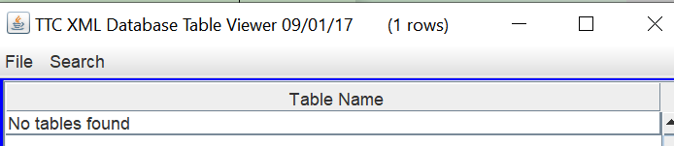

Figure 8.1.2 (Search window)

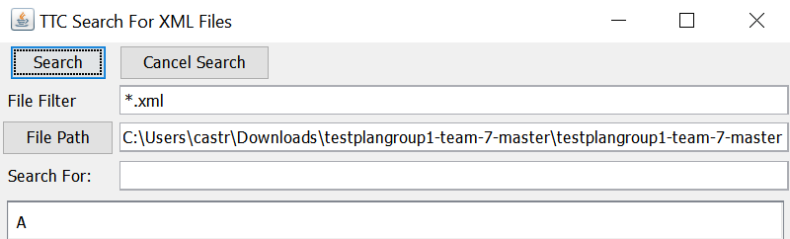

Figure 8.1.3 (Search results for “Constraint”)

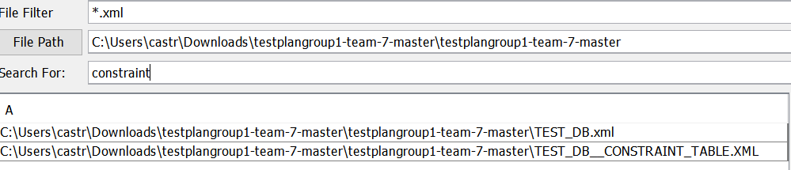

Figure 8.2.1

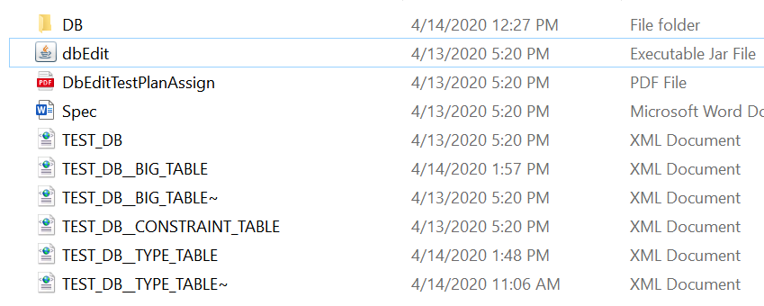

Figure 8.2.2

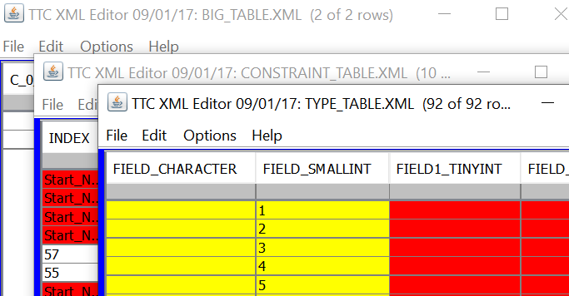

Figure 8.3.1

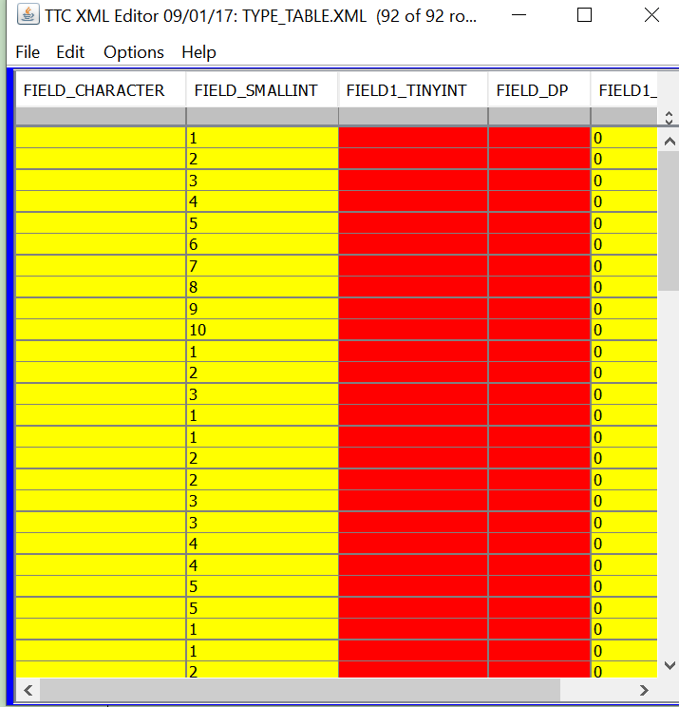

Figure 8.4.1

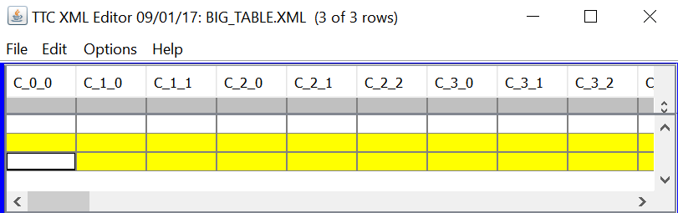

Figure 8.4.2

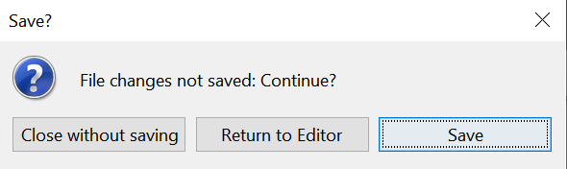

Figure 8.4.3

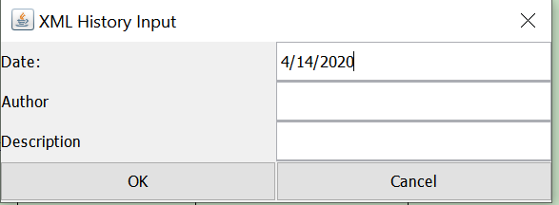

Figure 8.4.4

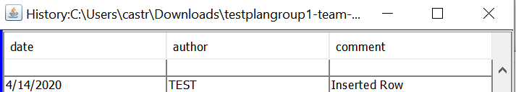

Figure 8.5.1
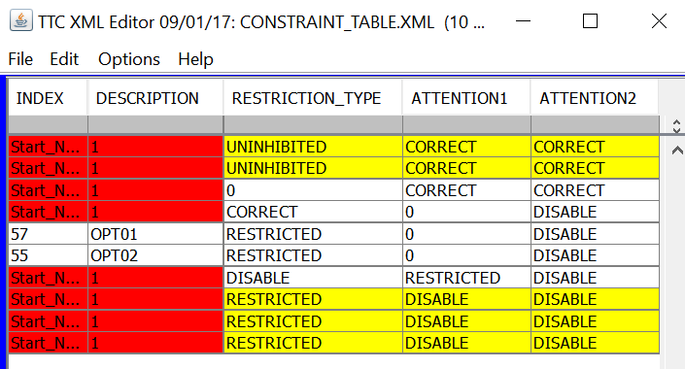

Figure 8.5.2

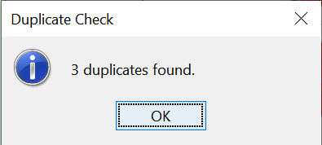

Figure 8.6.1

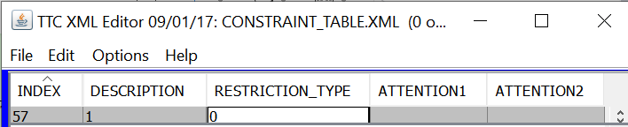

Figure 8.6.2

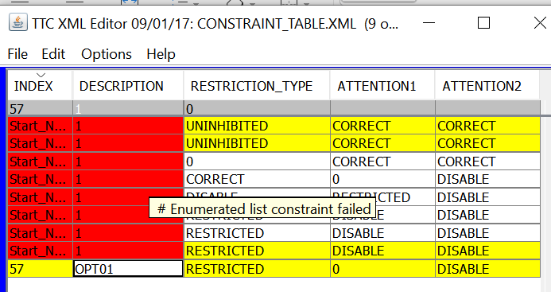

Figure 8.6.3

